290220199

<https://revistaseug.ugr.es/index.php/RELIEVE/issue/archive>

Go to the website using the based URL.

You will get archive page like below

Change the website language version to English.

Scroll little bit down you will get article list like below.

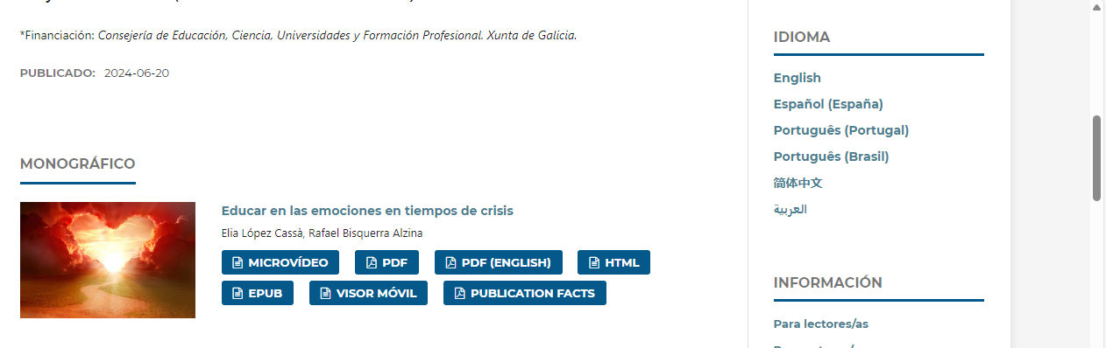

Capture and click article title

You will get article page like below.

Click here to download pdf

Capture DOI